# Specifications for stepper motor PCB design and lidar usage

## Mechanical layout

The components of the PCB should be placed on the top layer, the only exception is the pin headers which connects to the motherboard beneath the PCB. The maximum PCB size dimensions are shown in the picture below(yellow outline).

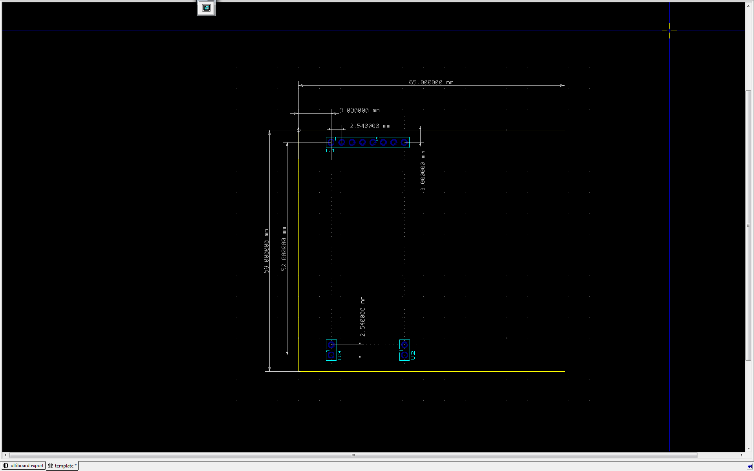

## Connections

U3 provides 7.4V, U2 provides GND. The current of the supply is limited using a Fuse, beware of the fuse ratings when designing the motor drive.

The pins of U1 are enumerated from 0 to 8(left to right as shown in picture) and connects according to the diagram below.

|  |  |
| --- | --- |
| PCB Pin | MyRIO pin |
| 1 | DIO 7 |
| 2 | DIO 6 |
| 3 | DIO 5 |
| 4 | DIO 4 |
| 5 | DIO 3 |
| 6 | DIO 2 |
| 7 | DIO 1 |
| 8 | DIO 0 |

## Lidar sensors

The lidar sensors connects to the diagram below.

|  |  |
| --- | --- |
| Sensor | Pin |
| Sensor 1 | AI 0 |
| Sensor 2 | AI 1 |
| Sensor 3 | AI 2 |
| Sensor 4 | AI 3 |